**MOTHERBOARD COMPONENTS**

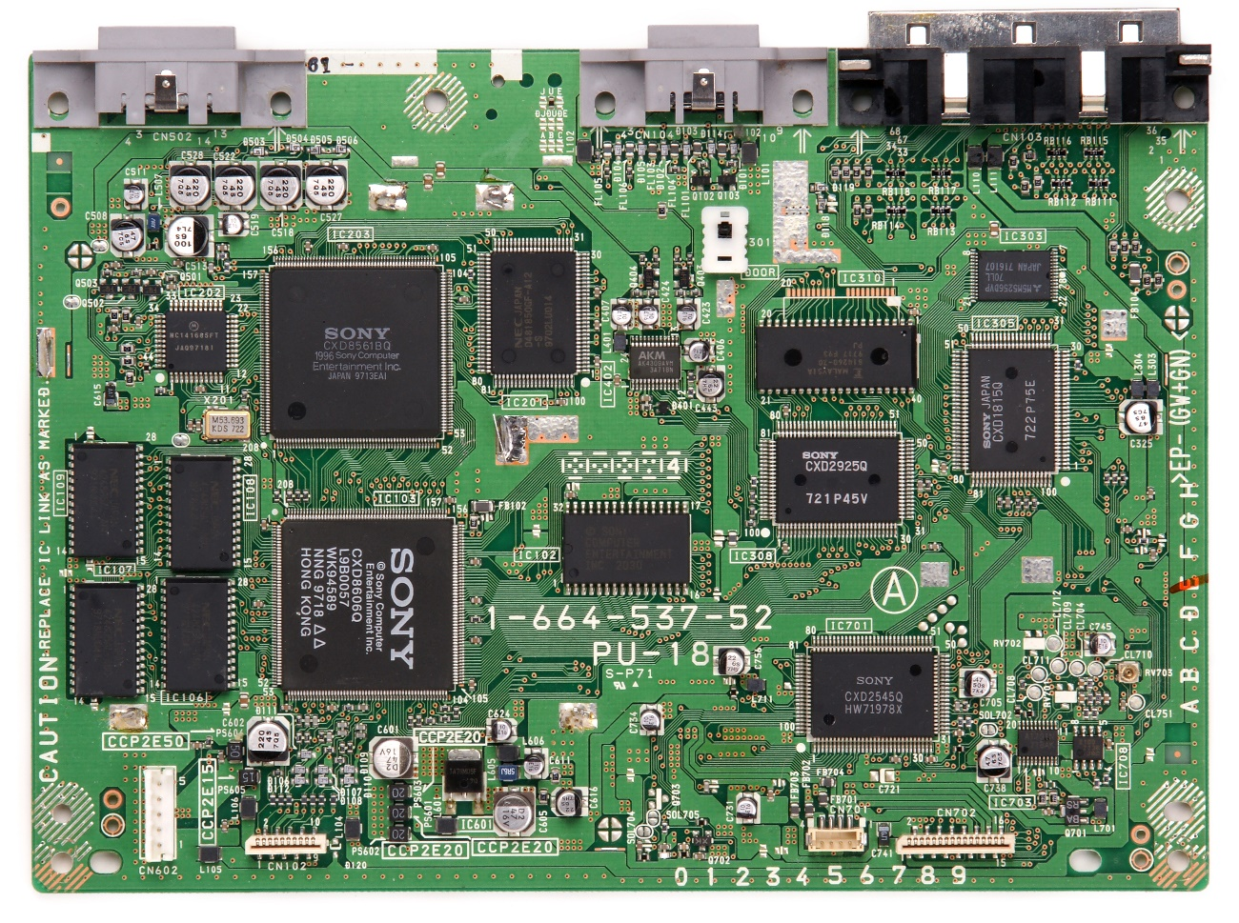

PCB: Printed circuit board is a printed circuit board, as are all motherboards. These boards serve as a base to include a multitude of components and interconnect them with each other through a network of traced tracks or conductors that are printed on the board.

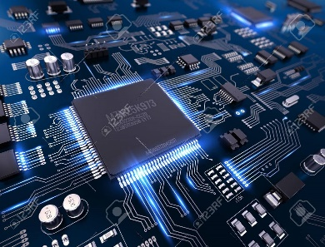

ç

Oscillator: The quartz oscillator. It is a key piece for the operation of the system. This crystal oscillator uses a small piece of quartz crystal inside, and works by distorting this crystal using an electric field. When voltage is applied to the electrode, a typical property of this crystal known as electrostriction or reverse piezoelectricity is unleashed.

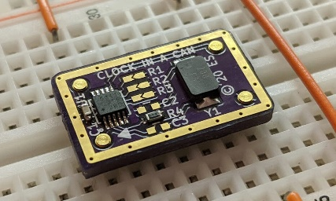

[Esta foto](https://www.electronics-lab.com/clock-oscillator-mini-package-clock-can/) de Autor desconocido está bajo licencia [CC BY-SA](https://creativecommons.org/licenses/by-sa/3.0/)

VRM: This voltage regulator module is a circuit that, as its name indicates, can regulate the voltage of its input to adapt it to the needs required by other components, such as the CPU. Therefore, the VRM takes a voltage from the power supply, such as 12v, 5v or 3.3v, and converts it into lower voltages such as 1.2v, 1v, 0.8v, etc., which are what the CPU will work with. Around the CPU, you can find some essential elements for this task of modifying and guaranteeing the voltage supply to the brain of the system, such as capacitors, choke, PWM chip and MOSFET.

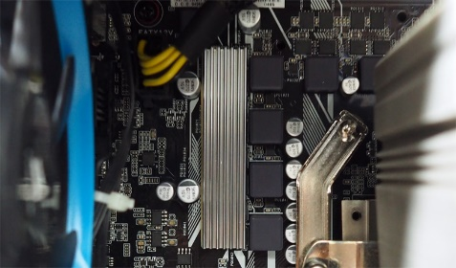

[Esta foto](https://www.riscascape.net/archives/11987) de Autor desconocido está bajo licencia [CC BY](https://creativecommons.org/licenses/by/3.0/)

Integrated sound: It is a DSP (Digital Signal Processor) in which all digital audio signals can be processed, both those entering and those leaving. This controlling the signals that enter through the jacks (or other type of audio port) of the microphone or the output for

headphones, speakers…

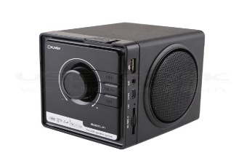

Integrated NIC: The integrated network card or integrated network adapter It will be in charge of controlling the WiFi, Ethernet and/or Bluetooth I/O.

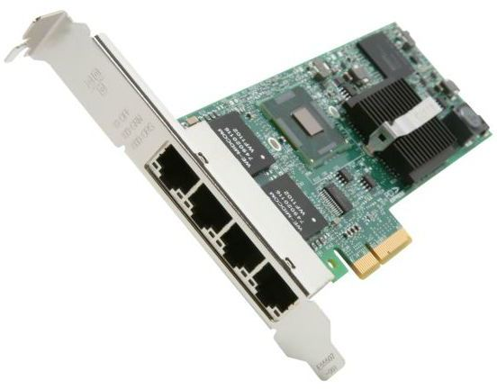

[Esta foto](http://superuser.com/questions/1050997/how-do-i-find-out-how-many-ethernet-ports-my-pcs-motherboard-supports) de Autor desconocido está bajo licencia [CC BY-SA](https://creativecommons.org/licenses/by-sa/3.0/)

Chipset: It is a fundamental part of the motherboard. It allows controlling the flow of information between the processor and other peripheral or integrated elements on the motherboard itself. The chipset goes hand in hand with the CPU, since all the information that enters or leaves the CPU to the peripherals controlled by the chipset will pass through it.

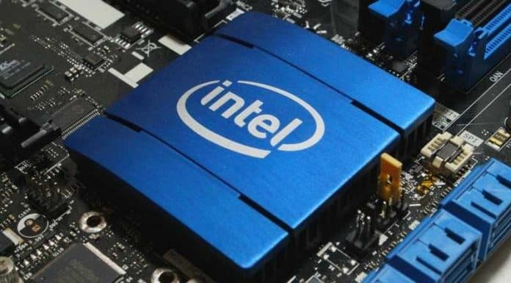

[Esta foto](https://pc-gaming.it/chipset-intel-h370-b360-h310-nel-2018/) de Autor desconocido está bajo licencia [CC BY-NC](https://creativecommons.org/licenses/by-nc/3.0/)

Onboard Cooling: We can find several cooling elements. It is formed by elements such as heatsinks, fans or shields

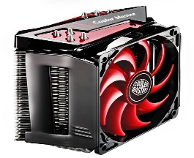

Expansion slots: All of them grouped in the lower-middle left area of ​​the motherboard. These slots, as the name suggests, are for expanding the capabilities of the system. Whether adding a dedicated graphics card, even a sound card, including video capturers, network cards, port expansion cards…

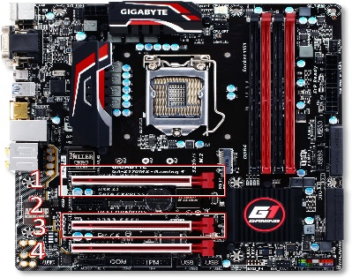

RAM Slot DIMM: The important slots on a motherboard are the DIMMs (SO-DIMMs in laptops), which are used to insert RAM memory modules. There are also side tabs that will hold the inserted RAM module so that it does not move.

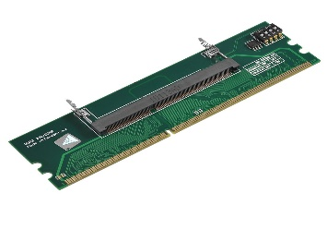

CPU Sockets: In some motherboards for miniPCs or laptops, the CPU is BGA type and is soldered on the motherboard, so they will lack this element. To be able to replace a CPU in these cases, it is not so simple, since it will involve desoldering and performing the so-called reballing.

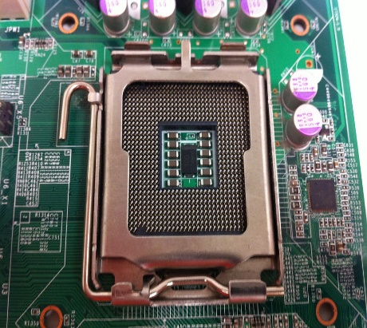

CMOS battery: A battery that maintains the time, date, hard disk, and other configuration settings in the CMOS memory. CMOS batteries are small and are attached directly to the motherboard.

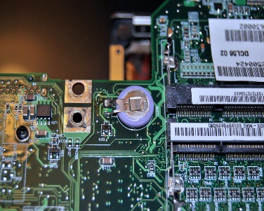

RTC chip: RTC stands for "real-time clock." It is an onboard, battery-powered semiconductor chip inside computers that stores information, including the system time and date.

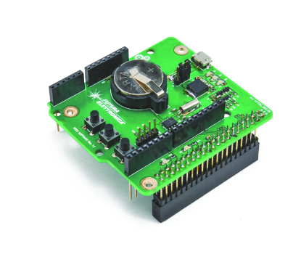

E/S ports: E/S stands for "input/output." E/S ports are the physical interfaces on a computer that allow it to communicate with external devices, such as a keyboard, mouse, printer, or USB drive.

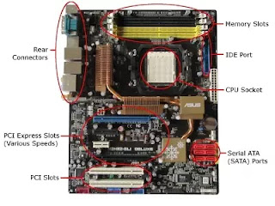

OnBoard LED/Display: An onboard LED or display is a light or screen built into the motherboard that provides information about the system's status, such as power, activity, or error codes.

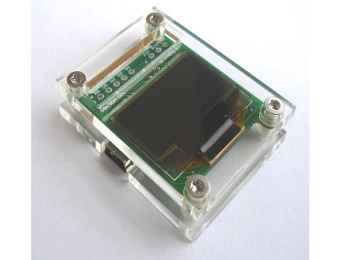

System panel connector header: The system panel connector header is a set of pins on the motherboard that connect to the wires from the case's power button, reset button, power LED, and HDD LED. These pins allow the user to control the system's power and monitor its status.

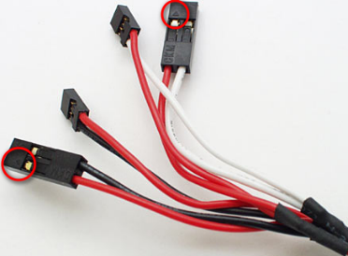

Clear CMOS jumper: The clear CMOS jumper is a small plastic connector on the motherboard that can be moved to reset the CMOS memory to its default settings. This can be useful if the system is not booting or if there are other issues with the configuration settings.

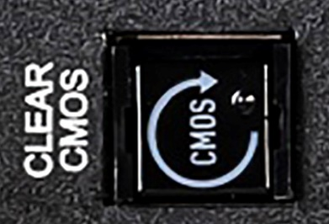

Super I/O is a type of chip on the motherboard that provides input/output functions, such as serial and parallel ports, floppy disk controllers, and PS/2 ports for keyboard and mouse.

:

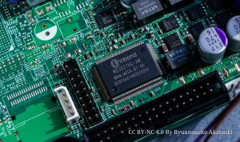

Mounting holes: Mounting holes are small holes on the motherboard that allow it to be attached to the case using screws or standoffs. These holes are usually located around the edges of the motherboard.

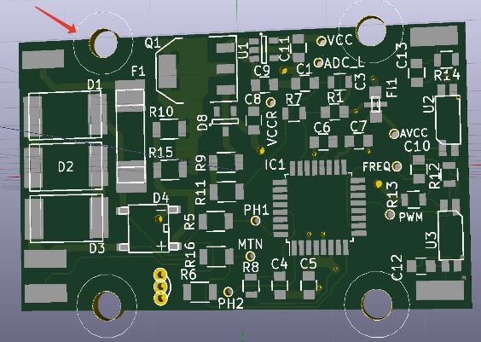

Fan connectors: Fan connectors are ports on the motherboard that allow the user to connect fans to the system. These fans can help cool the CPU, GPU, or other components.

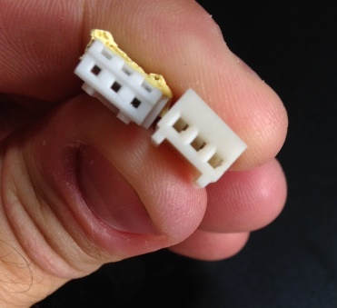

Power connectors: Power connectors are ports on the motherboard that allow the user to connect the power supply to the system. These connectors provide power to the motherboard and other components

